**ARYAMAN MISHRA**

**19BCE1027**

#include <iostream>

#include<bits/stdc++.h>

#include<conio.h>

using namespace std;

int main() {

int choice;

int i,j,k,n,m,sum=0,x,y,h,temp,ele,count;

vector <int> a(n),b,l;

map <int,int> mp;

cout << "Enter 1 for SCAN,2 for FCFS,3 for SSTF,4 for CSCAN,5 for LOOK,6 for CLOOK \n";

cin>>choice;

switch (choice) {

case 1://SCAN

system("cls");

cout<<"Enter the size of disk\n";

cin>>m;

cout<<"Enter number of requests\n";

cin>>n;

cout<<"Enter the requests\n";

//vector <int> a(n),b;

for(i=0;i<n;i++){

cin>>a[i];

}

for(i=0;i<n;i++){

if(a[i]>m){

cout<<"Error, Unknown position "<<a[i]<<"\n";

return 0;

}

}

cout<<"Enter the head position\n";

cin>>h;

//int temp=h;

temp=h;

a.push_back(h);

a.push_back(m);

a.push_back(0);

sort(a.begin(),a.end());

for(i=0;i<a.size();i++){

if(h==a[i])

break;

}

k=i;

if(k<n/2){

for(i=k;i<a.size();i++){

b.push_back(a[i]);

}

for(i=k-1;i>=0;i--){

b.push_back(a[i]);

}

}

else{

for(i=k;i>=0;i--){

b.push_back(a[i]);

}

for(i=k+1;i<a.size();i++){

b.push_back(a[i]);

}

}

temp=b[0];

cout<<temp;

for(i=1;i<b.size();i++){

cout<<" -> "<<b[i];

sum+=abs(b[i]-temp);

temp=b[i];

}

cout<<'\n';

cout<<"Total head movements = "<< sum<<'\n';

cout<<"Average head movement = "<<(float)sum/n<<'\n';

break;

case 2://FCFS

system("cls");

cout<<"Enter the size of disk\n";

cin>>m;

cout<<"Enter number of requests\n";

cin>>n;

cout<<"Enter the requests\n";

// creating an array of size n

//vector <int> a(n);

for(i=0;i<n;i++){

cin>>a[i];

}

for(i=0;i<n;i++){

if(a[i]>m){

cout<<"Error, Unknown position "<<a[i]<<"\n";

return 0;

}

}

cout<<"Enter the head position\n";

cin>>h;

// head will be at h at the starting

temp=h;

cout<<temp;

for(i=0;i<n;i++){

cout<<" -> "<<a[i]<<' ';

// calculating the difference for the head movement

sum+=abs(a[i]-temp);

// head is now at the next I/O request

temp=a[i];

}

cout<<'\n';

cout<<"Total head movements = "<< sum<<'\n';

break;

case 3://SSTF

system("cls");

cout<<"Enter the size of disk\n";

cin>>m;

cout<<"Enter number of requests\n";

cin>>n;

cout<<"Enter the requests\n";

//creating two arrays, array a will store the input

//I/O requests and array b will store the output

//vector <int> a(n),b;

//creating a map to store the count of each element

//in the array a.

//map <int,int> mp;

for(i=0;i<n;i++){

cin>>a[i];

mp[a[i]]++;

}

for(i=0;i<n;i++){

if(a[i]>m){

cout<<"Error, Unknown position "<<a[i]<<"\n";

return 0;

}

}

cout<<"Enter the head position\n";

cin>>h;

//int temp=h;

temp=h;

//int ele;

b.push_back(h);

//int count=0;

count=0;

while(count<n){

//initially taking diff to be very large.

int diff=999999;

//traversing in map to find the least difference

for(auto q:mp){

if(abs(q.first-temp)<diff){

ele=q.first;

diff=abs(q.first-temp);

}

}

//deleting the element that has the least

//difference from the map

mp[ele]--;

if(mp[ele]==0){

mp.erase(ele);

}

//adding that element to our output array.

b.push_back(ele);

temp=ele;

count++;

}

//printing the output array

cout<<b[0];

temp=b[0];

for(i=1;i<b.size();i++){

cout<<" -> "<<b[i];

sum+=abs(b[i]-temp);

temp=b[i];

}

cout<<'\n';

cout<<"Total head movements = "<< sum<<'\n';

cout<<"Average head movement = "<<(float)sum/n<<'\n';

break;

case 4://CSCAN

//int i,j,k,n,m,sum=0,x,y,h;

system("cls");

cout<<"Enter the size of disk\n";

cin>>m;

cout<<"Enter number of requests\n";

cin>>n;

cout<<"Enter the requests\n";

//vector <int> a(n),b;

for(i=0;i<n;i++){

cin>>a[i];

}

for(i=0;i<n;i++){

if(a[i]>m){

cout<<"Error, Unknown position "<<a[i]<<"\n";

return 0;

}

}

cout<<"Enter the head position\n";

cin>>h;

//int temp=h;

temp=h;

a.push_back(h);

a.push_back(m);

a.push_back(0);

sort(a.begin(),a.end());

for(i=0;i<a.size();i++){

if(h==a[i])

break;

}

k=i;

if(k<n/2){

for(i=k;i<a.size();i++){

b.push_back(a[i]);

}

for(i=0;i<=k-1;i++){

b.push_back(a[i]);

}

}

else{

for(i=k;i>=0;i--){

b.push_back(a[i]);

}

for(i=a.size()-1;i>=k+1;i--){

b.push_back(a[i]);

}

}

temp=b[0];

cout<<temp;

for(i=1;i<b.size();i++){

cout<<" -> "<<b[i];

sum+=abs(b[i]-temp);

temp=b[i];

}

cout<<'\n';

cout<<"Total head movements = "<< sum<<'\n';

cout<<"Average head movement = "<<(float)sum/n<<'\n';

break;

case 5://LOOK

//int i,j,k,n,m,sum=0,x,y,h;

system("cls");

cout<<"Enter the size of disk\n";

cin>>m;

cout<<"Enter number of requests\n";

cin>>n;

cout<<"Enter the requests\n";

//vector <int> a(n),l;

for(i=0;i<n;i++){

cin>>a[i];

}

for(i=0;i<n;i++){

if(a[i]>m){

cout<<"Error, Unknown position\n";

return 0;

}

}

cout<<"Enter the head position\n";

cin>>h;

a.push_back(h);

sort(a.begin(),a.end());

for(i=0;i<a.size();i++){

if(h==a[i])

break;

}

k=i;

if(k<n/2){

for(i=k;i<a.size();i++){

l.push_back(a[i]);

}

for(i=k-1;i>=0;i--){

l.push_back(a[i]);

}

}

else{

for(i=k;i>=0;i--){

l.push_back(a[i]);

}

for(i=k+1;i<a.size();i++){

l.push_back(a[i]);

}

}

//int temp=l[0];

temp=l[0];

cout<<temp;

for(i=1;i<l.size();i++){

cout<<" -> "<<l[i]<<' ';

sum+=abs(l[i]-temp);

temp=a[i];

}

cout<<'\n';

cout<<"Total head movements = "<< sum<<'\n';

break;

case 6://CLOOK

system("cls");

int i,j,k,n,m,sum=0,x,y,h;

cout<<"Enter the size of disk\n";

cin>>m;

cout<<"Enter number of requests\n";

cin>>n;

cout<<"Enter the requests\n";

vector <int> a(n),l;

for(i=0;i<n;i++){

cin>>a[i];

}

for(i=0;i<n;i++){

if(a[i]>m){

cout<<"Error, Unknown position\n";

return 0;

}

}

cout<<"Enter the head position\n";

cin>>h;

a.push_back(h);

sort(a.begin(),a.end());

for(i=0;i<a.size();i++){

if(h==a[i])

break;

}

k=i;

if(k<n/2){

for(i=k;i<a.size();i++){

l.push_back(a[i]);

}

for(i=0;i<k;i++){

l.push_back(a[i]);

}

}

else{

for(i=k;i>=0;i--){

l.push_back(a[i]);

}

for(i=a.size()-1;i>k;i--){

l.push_back(a[i]);

}

}

int temp=l[0];

cout<<temp;

for(i=1;i<l.size();i++){

cout<<" -> "<<l[i]<<' ';

sum+=abs(l[i]-temp);

temp=a[i];

}

cout<<'\n';

cout<<"Total head movements = "<< sum<<'\n';

break;

}

return 0;

}

SCAN

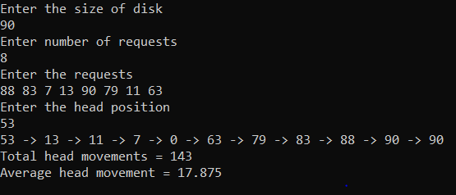

FCFS

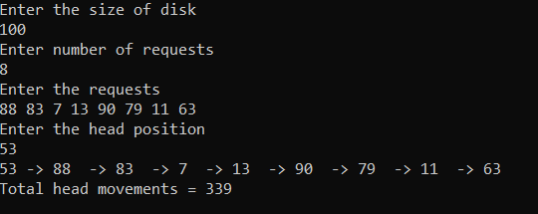

SSTF

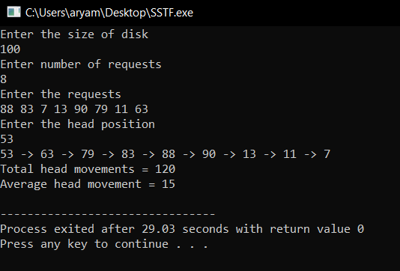

CSCAN

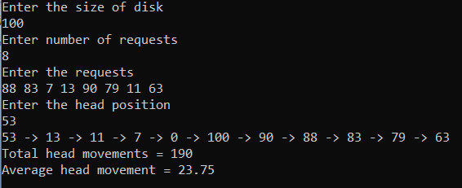

LOOK

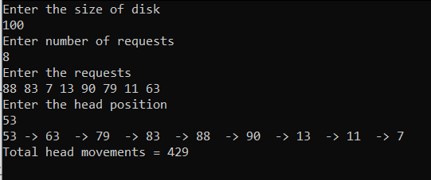

CLOOK

